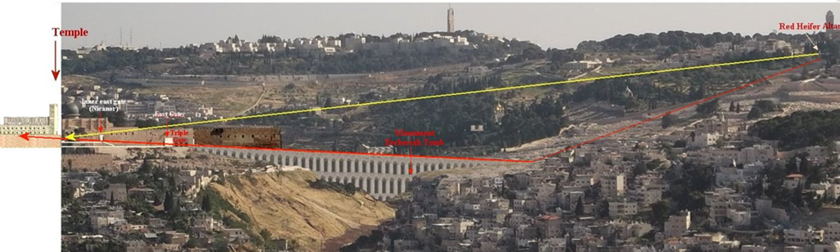Here are a few pictures that I picked up along the way that will help visualize the bridge between the Eastern Gate and the Mt. of Olives. Over the years, I’ve lost the original references for these.

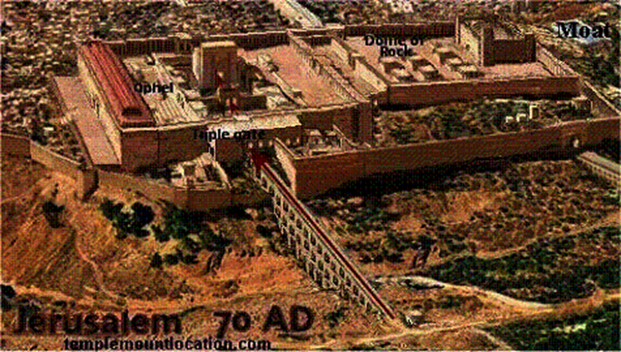

It would have been across this bridge that the Red Heifer would have been taken to sacrifice during the Second Temple Period. Possibly, even the route of Messiah to His crucifixion point.

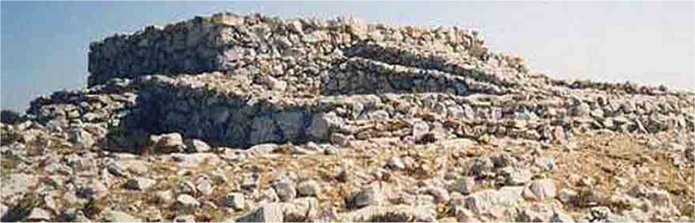This is a photo of what is believed to be the third altar on the Mt. of Olives. There appears to be an altar area and a clean storage area where the ashes of the Red Heifer would have been stored.

Possible site, or near site of Crucifixion.